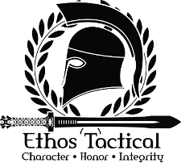
Basic Pistol Class Information
5 Hour Class (1 Hour Range & Firearm Safety & 4 Hours Range Instruction)
Per Student Cost - $150.00
All students must bring a valid Illinois F.O.I.D. card, pistol, and at least 100 rounds of weapon specific ammunition.
Material Covered:
- Firearm & Range Safety
- Basic Pistol Handling/Manipulation/Skills
- Dry Fire
- Live Fire
- Pistol Cleaning
All students will be provided detailed course outlines for classes along with personalized one on one instruction. Please contact us for class times and schedules.
Ethos specializes in group classes for family, friends, and co-workers. Contact us for group pricing and scheduling.
Ethos instructors travel to you. If you are located out of the Central Illinois area, we can come to you. Ethos instructors have traveled as far as California to teach courses. Contact us for more information and travel requirements.

